1.
Install Wireshark on your laptop, start a capture on your main network interface, and visit any website (like instagram.com). Stop the capture and note down the protocol names you see in the packet list.

- After installing Wireshark and starting capture on your main interface (like Wi-Fi), visiting instagram.com typically shows protocols such as:

    - DNS – Resolving domain names
    - TCP – Reliable transport
    - SSL – Encryption
    - HTTP / HTTPS – Web data transfer
    - ARP – Address resolution

2.
Pick any 3 packets from your Wireshark capture and identify which OSI layer each packet mainly represents (for example, HTTP for Application layer, TCP for Transport layer, etc.).<br><br><em><strong>Hint:</strong> Use the Protocol column and Info details in Wireshark to help you map protocols to OSI layers.</em>

Packet Example | Protocol | OSI Layer | Description
HTTP GET Request | HTTP | Application (Layer 7) | Fetches web content from Instagram’s server
TCP Segment | TCP | Transport (Layer 4) | Ensures reliable delivery of data packets
ARP Request | ARP | Data Link (Layer 2) | Maps IP address to MAC address for local delivery

3.
Create a colorful diagram of the OSI Model using any drawing tool (MS Paint, Canva, or even paper and upload a photo). For each layer, add a real-world example from apps you use daily (e.g., WhatsApp uses the Application layer, Instagram images use the Presentation layer, etc.).

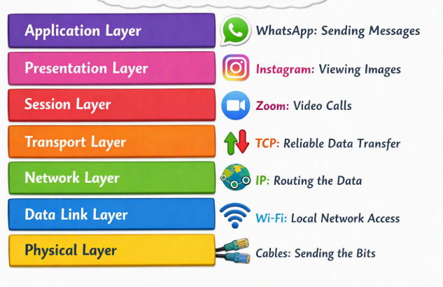

4.
Explain how sending a message on WhatsApp travels through at least 4 layers of the OSI Model, describing what happens at each layer in your own words.<br><br><em><strong>Hint:</strong> Think about how your message is typed, packaged, sent over the internet, and received.</em>

When you send a message:
- Application Layer (7): You type and hit send — WhatsApp formats your message.
- Transport Layer (4): TCP breaks it into segments and ensures delivery.
- Network Layer (3): IP routes those segments across the internet to the recipient’s phone.
- Data Link Layer (2): Wi-Fi or mobile network frames the data for local transmission.
- Physical Layer (1): Electrical or radio signals carry the bits through cables or airwaves.

